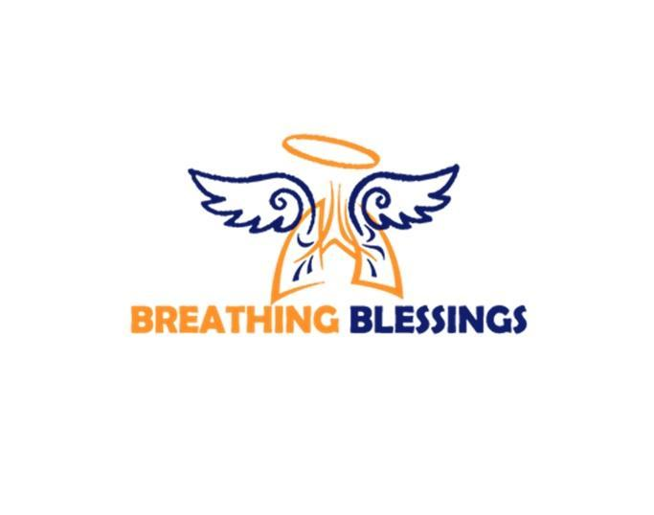

2023 Scholarship Application
Breathing Blessings is offering an opportunity to access funds that will assist a deserving student on their educational journey.
Scholarships are being offered March 6 - June 1, 2023, to the following students:
- High school seniors who will graduate in the Spring of 2023 and plan to enroll in a community college, technical school, or a four-year college/university in the Fall.
Eligibility Requirements
- Must meet income requirements. * See income requirements document (page 3)
- Must reside in one of the following counties:
  - Caroline County
  - City of Fredericksburg
  - King George
  - Prince William County
  - Spotsylvania County
  - Stafford County
- Complete Breathing Blessings Scholarship application. * See application (page 4)
High School Applicants:
- Must be graduating in the Spring of 2023.
- Must have a GPA of 2.5 or higher.
- Must have applied and been accepted to a community college, technical school, or four-year college/university.
- Must have two (2) letters of recommendation. Recommendations may come from:
School Counselor, Teacher, Principal, Employer, Pastor, etc. All letters must be on official letterhead and signed.
- Copy of official enrollment letter (if you have been conditionally accepted, you will be asked to provide your official letter at a later time).
- Submit a brief biography.

ESSAY TOPIC
- What is one thing you could do today to improve our local community? How would you accomplish this goal?

ESSAY REQUIREMENTS

Submission must be:
- Double spaced
- 300 to 500 words

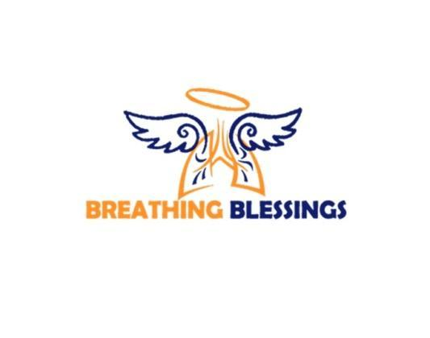

Breathing Blessings Scholarship Income Requirements
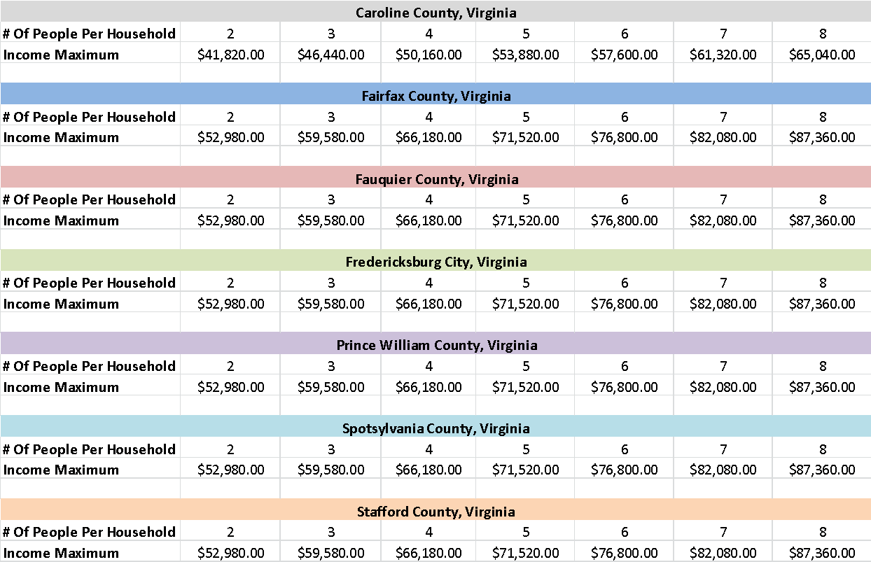

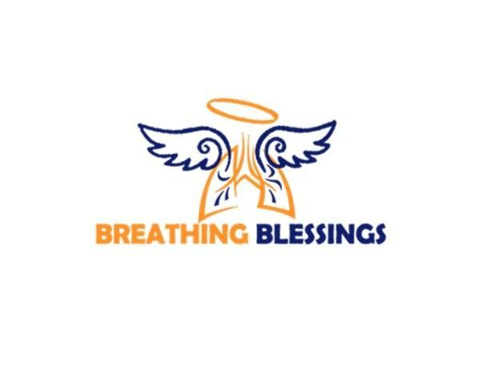

Scholarship Application (*Applications received after June 1, 2023, and/or incomplete, will NOT be processed)
Applicant Information
Full Name: |  |  |  | Date of Birth:
 | Last | First | M.I.

Address:
 | Street Address | Apartment/Unit #

 | City / County | State | ZIP Code

Phone: |  | Email:

School you currently attend: | Current GPA:

School you plan to attend: ___________________________________________________________________

Field of study:

Application Checklist
Completed application? | YES  ☐
Essay attached? | YES  ☐
Brief biography attached? | YES  ☐
Acceptance letter attached (Due no later than June 1, 2023)? | YES  ☐
Two letters of recommendation attached? | YES  ☐
Disclaimer and Signature
All documentation must be received or postmarked by June 1, 2023.
​Once you have been notified that you are a Breathing Blessing Scholarship recipient, you will need to submit your official acceptance letter from the institution to Breathing Blessings no later than July 7, 2023.
Applicant’s Signature: |  | Date:
Parent or Guardian signature  (If applicant is under age 18): |  | Date:

